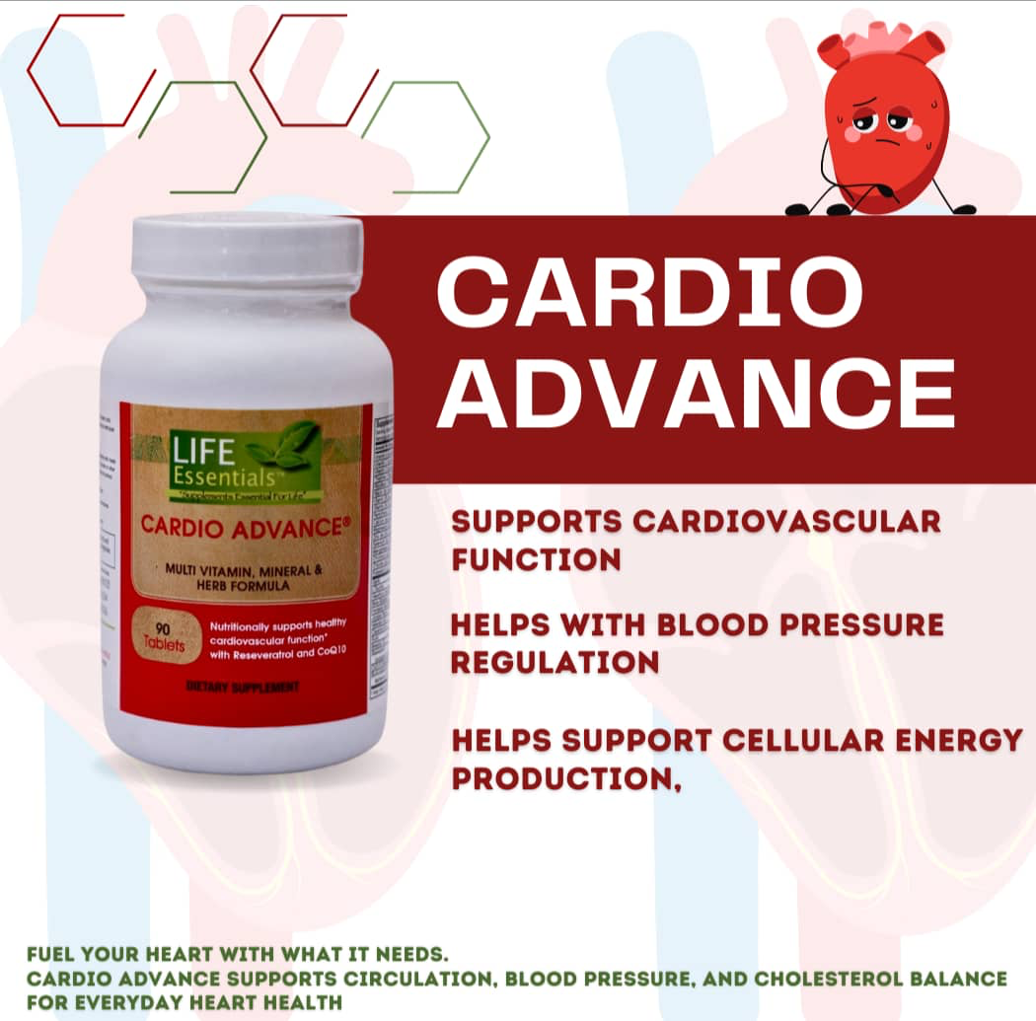

Cardio Advance

Key Benefits

1. Supports Cardiovascular Function

2. Helps Regulate Blood Pressure

3. Boosts Cellular Energy Production

4. Supports Cholesterol Balance

5. Antioxidant Protection
2.

Soursop Benefits
- Immune System Support: The combination of Soursop (Graviola), Moringa, and Black Seed Oil is potent for strengthening the body's natural defenses. These ingredients are rich in Vitamin C, iron, and phytochemicals that help fight off oxidative stress.
- Anti-Inflammatory Action: Turmeric (curcumin) and Oregano are powerful natural anti-inflammatories. They are often used to support joint health, reduce swelling, and manage systemic inflammation.
- Mineral & Thyroid Support: Sea Moss is famous for containing up to 92 of the 102 minerals the body needs, including iodine, which is essential for healthy thyroid function and metabolic balance.
- Digestive Wellness: Many of these "bitters" (like Soursop and Oregano) help stimulate digestive enzymes, potentially reducing bloating and improving gut health.

3

Miira-cell Benefits
- Cellular Regeneration: The "stem cell" approach aims to trigger the body's natural ability to repair and replace damaged cells, which can help with anti-aging and faster recovery from illness or injury.
- Enhanced Immune Function: Ingredients like Soursop, Pomegranate, and Vitamin C-rich fruits (kiwi, orange, strawberry) provide a massive antioxidant boost to help the body neutralize free radicals.
- Skin Health & Anti-Aging: By supporting collagen production and cellular repair, it is often used to improve skin elasticity, reduce fine lines, and promote a "glow" from within.
- Digestive & Metabolic Support: The fiber and phytonutrients found in the fruit extracts (like Apple and Grape) support healthy digestion and can help stabilize energy levels throughout the day.
- Blood Circulation: Many of the dark berries and pomegranate components are known to support cardiovascular health by improving blood flow and vessel integrity.

4. 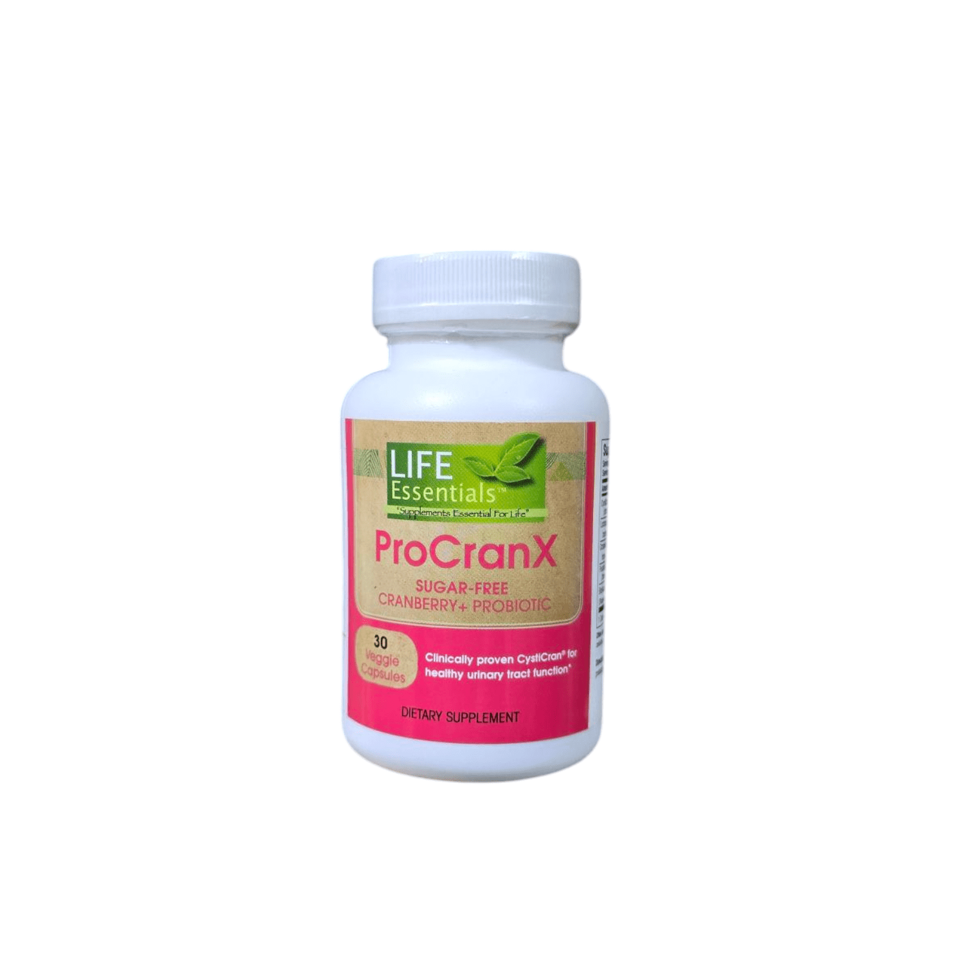

- Urinary Tract Health: The concentrated cranberry extract (rich in PACs) helps prevent harmful bacteria from adhering to the bladder wall, reducing the risk of UTIs.
- Microbiome Balance: Contains "friendly" bacteria (Lactospore) that survive stomach acid to populate the gut and vaginal tract with healthy flora.
- Digestive Comfort: Enhanced with BioAccelerators (like Ginger and Bioperine) to improve nutrient absorption and reduce digestive distress.
- Antioxidant Defense: Provides a sugar-free way to get the protective benefits of cranberries without the acidity or calories of juice.
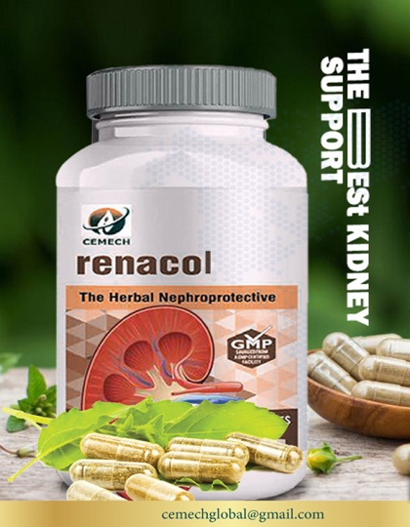
5.

Renacol is primarily a kidney and urinary health supplement. Depending on the specific brand available in your region (likely Cemech Renacol or Life Source Renacol), its benefits range from supporting renal detoxification to preventing infections.

Benefits
- Kidney Support & Detoxification: Renacol is frequently used to guard the kidneys against the damaging effects of nephrotoxins. It helps support the vital detoxification functions of the renal system and improves overall renal health.
- Urinary Tract Health (UTI Prevention): For the sachet/powder versions, the combination of Cranberry extract and D-Mannose prevents harmful bacteria (like E. coli) from sticking to the urinary tract walls, reducing the risk of recurrent UTIs.
- Urogenital Balance: In women, it helps maintain healthy vaginal flora and acidity, which can assist in managing bacterial vaginosis or yeast-related issues.
- Antibiotic Support: It is often used as a complementary therapy alongside antibiotics to help reduce bacterial resistance and speed up recovery from infections.
6

• Detoxification Support: The patches are designed to "draw out" toxins, heavy metals, and metabolic waste through the sweat glands in the feet while you sleep.
• Improved Sleep Quality: Many users report falling asleep faster and experiencing a deeper, more restful sleep cycle after consistent application.
• Reduced Physical Fatigue: By supporting the body's natural waste removal process, these patches are often used to help reduce feelings of lethargy and boost morning energy levels.
• Stress Relief: The warming sensation and the ritual of the foot patch can promote relaxation and a sense of calm.
• Relief from Minor Aches: Some users find that the patches help reduce swelling and minor joint or muscle discomfort in the lower extremities.

